There are 5 segments results: Swim (Rank, Time, Pace)   
Transition 1 (Time only)  
Bike (Rank, Time, Pace)  
Transition 2 (Time only)  
Run (Rank, Time, Pace)

**Segment ranking** **– Rnk -** represents an athlete place after all previous segments combined.   
Example: Bike ranking is a competitor place in their division after the bike segment, including swim, transition 1 and bike time (time from swim start to bike |second transition| entry).  
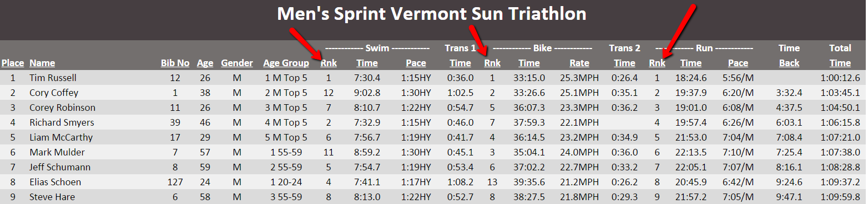

**Segment time – Time** - is pure one segment time in all pages ***except*** *Age Group Results Page (all previous segments times compiled)*Example: Bike time is the time from bike (first transition) exit to bike (second transition) entry.  
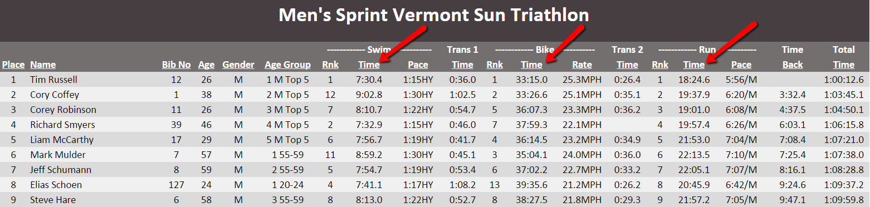

**Segment Pace – Pace** or **Rate** – is the pace for selected one segment  
Example: Swim Pace - 1:15HY - is the 1 minute 15 seconds per 100 yards  
 Bike Rate – 25.3MPH – is miles per hour average speed  
 Run Pace – 5:56 – is 5 minutes 56 seconds per 1 mile  
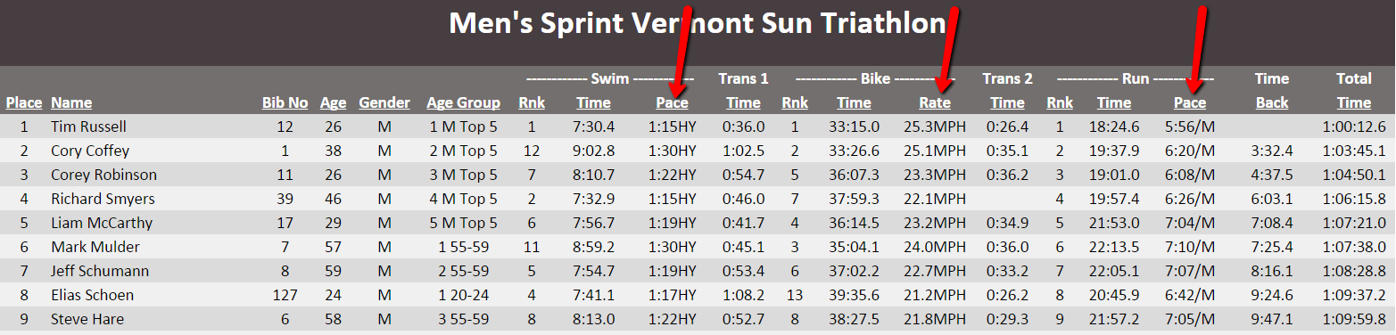

**Time Back** – is the time finishing behind 1st place winner in your gender and division.