There are 5 segments results: Swim (Rank, Time, Pace)
Transition 1 (Time only)
Bike (Rank, Time, Pace)
Transition 2 (Time only)
Run (Rank, Time, Pace)
Segment ranking – Rnk - represents an athlete place after all previous segments combined.
Example: Bike ranking is a competitor place in their division after the bike segment, including swim, transition 1 and bike time (time from swim start to bike |second transition| entry).
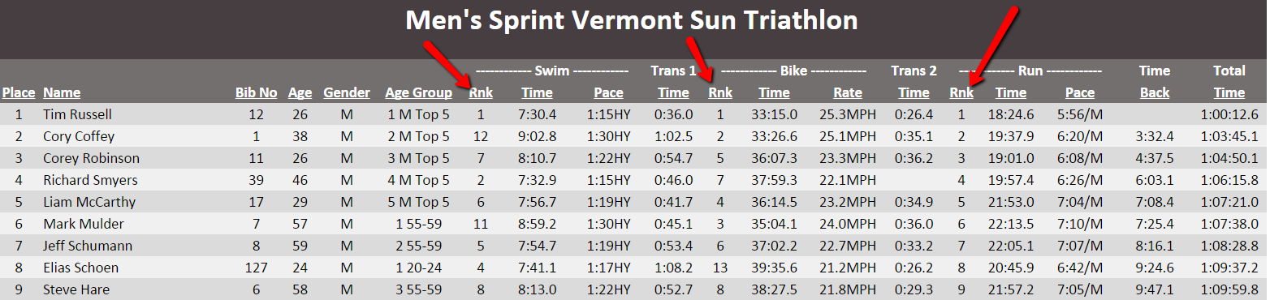
Segment time – Time - is pure one segment time in all pages except Age Group Results Page (all previous segments times compiled)
Example: Bike time is the time from bike (first transition) exit to bike (second transition) entry.
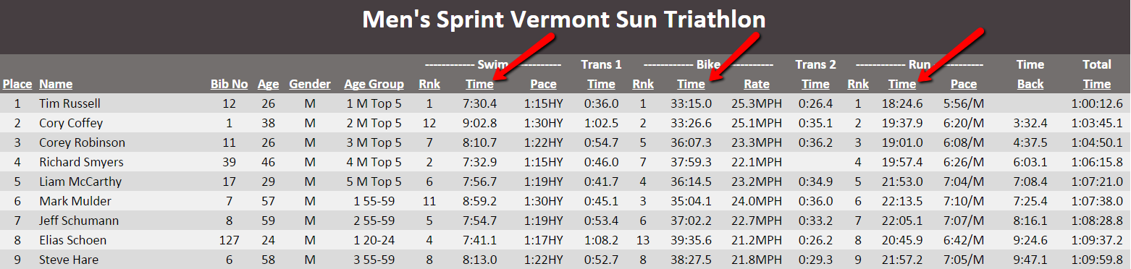
Segment Pace – Pace or Rate – is the pace for selected one segment
Example: Swim Pace - 1:15HY - is the 1 minute 15 seconds per 100 yards
Bike Rate – 25.3MPH – is miles per hour average speed
Run Pace – 5:56 – is 5 minutes 56 seconds per 1 mile
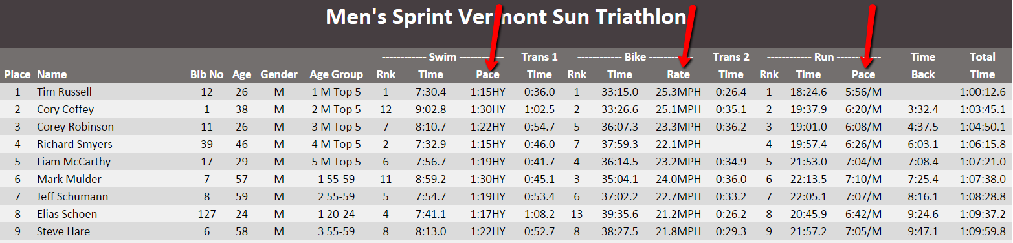
Time Back – is the time finishing behind 1st place winner in your gender and division.

